Prime Numbers
Let’s find all of the prime numbers less than 100.
1 | 2 | 3 | 4 | 5 | 6 | 7 | 8 | 9 | 10
11 | 12 | 13 | 14 | 15 | 16 | 17 | 18 | 19 | 20
21 | 22 | 23 | 24 | 25 | 26 | 27 | 28 | 29 | 30
31 | 32 | 33 | 34 | 35 | 36 | 37 | 38 | 39 | 40
41 | 42 | 43 | 44 | 45 | 46 | 47 | 48 | 49 | 50
51 | 52 | 53 | 54 | 55 | 56 | 57 | 58 | 59 | 60
61 | 62 | 63 | 64 | 65 | 66 | 67 | 68 | 69 | 70
71 | 72 | 73 | 74 | 75 | 76 | 77 | 78 | 79 | 80
81 | 82 | 83 | 84 | 85 | 86 | 87 | 88 | 89 | 90
91 | 92 | 93 | 94 | 95 | 96 | 97 | 98 | 99 | 100

- Cross off the number 1. The number 1 is called a unit. It is neither prime nor composite and is a factor of all counting numbers.
- Circle the number 2, and then cross off all other multiples of 2.
- Circle the number 3, and then cross off all other multiples of 3.
- Circle the number 5, and then cross off all other multiples of 5.
- Circle the number 7, and then cross off all other multiples of 7.
- Circle all of the remaining numbers—these are all of the prime numbers < 100!
Factors
Find all possible factors for the numbers given below

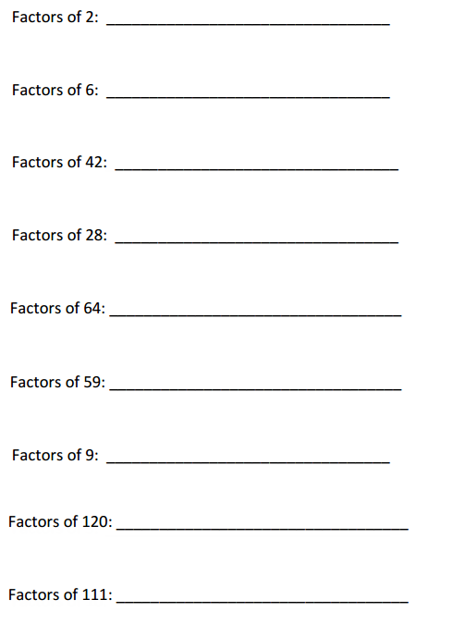

Greatest Common Factor
Find the greatest common factor of the provided 2 numbers 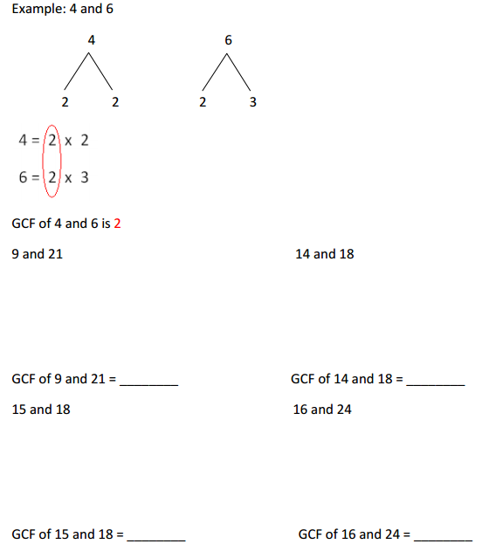

List the common factors of numbers and find the greatest number among them.

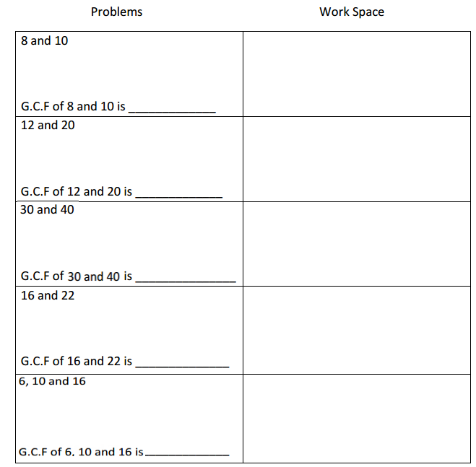

Least Common Multiple
- Identify the first three common multiples for the provided numbers. Determine the LCM.

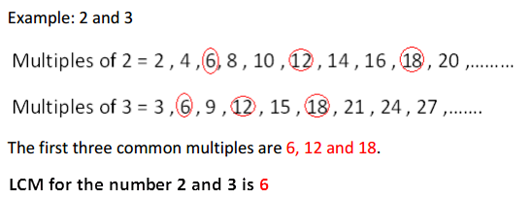

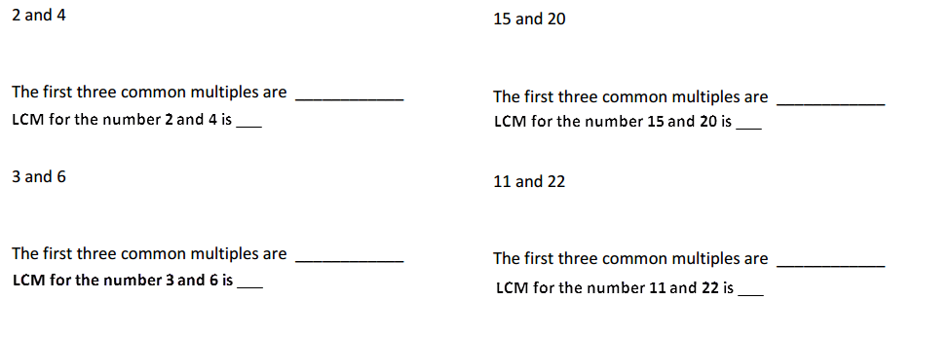

- Find the prime factors of the provided numbers and determine the LCM.
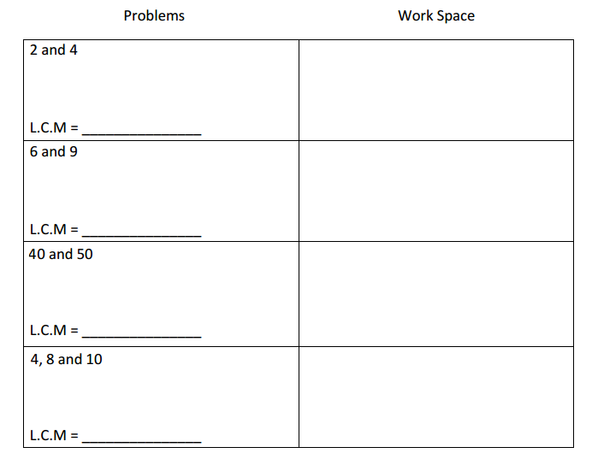
Integer
Represent the statements as positive and negative integers.
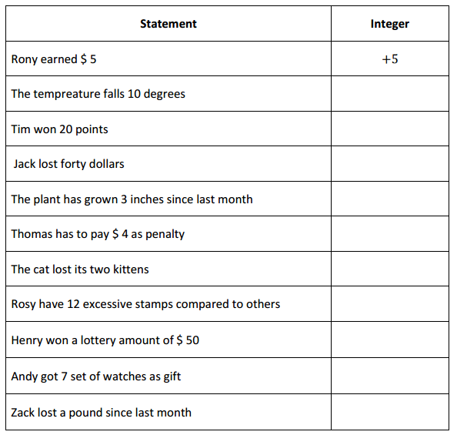

Use > or < or = sign to compare the integers:
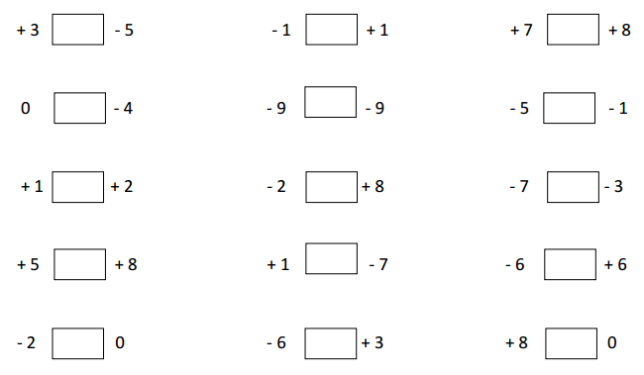
Circle the smallest number in each set:
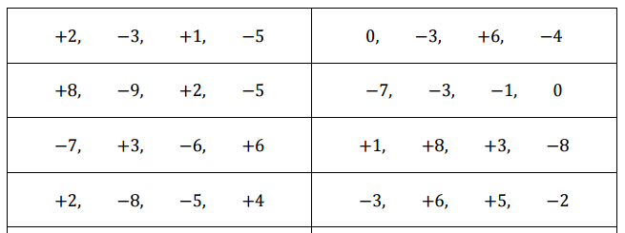

Arrange and write the numbers in increasing order:
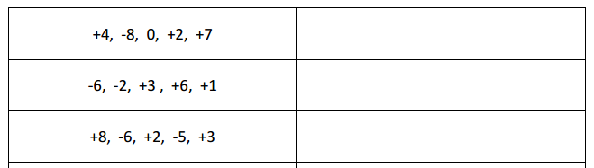
Arrange and write the numbers in decreasing order:
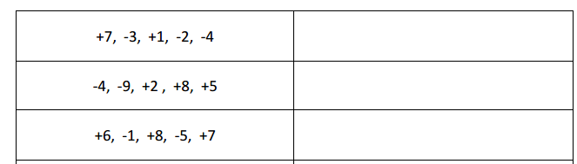

Add/Subtract the integers
